# Ideation document

## Language learning website

Purpose: In this term I want to create a language learning website like Duolingo and Lingualeo where you can learn new vocabulary and play simple language games. On my websites there will be three types of users: learners, contributors, and administrators. Learners will be able to add the words and collocations they learned to their vocabulary and see them on their personal page.

## [Git link](https://git.fhict.nl/I457345/languagelearning.git)

https://git.fhict.nl/I457345/languagelearning.git

<Content>: words

Content and entities: words and their translations, texts

Additional content variation: collocations (“find out”)

New entity: training texts

Extension: the statistics for how many games you have played and how many words you have learnt

On the page for registered users: you would have the words and word collections you have added and eventually your game scores.

## Sitemap:

* Home page
* All words
* Word
* Practice
  + Read text
  + Translate word
  + Pick translation
  + Result
* Random
* Register
* Login
* Profile

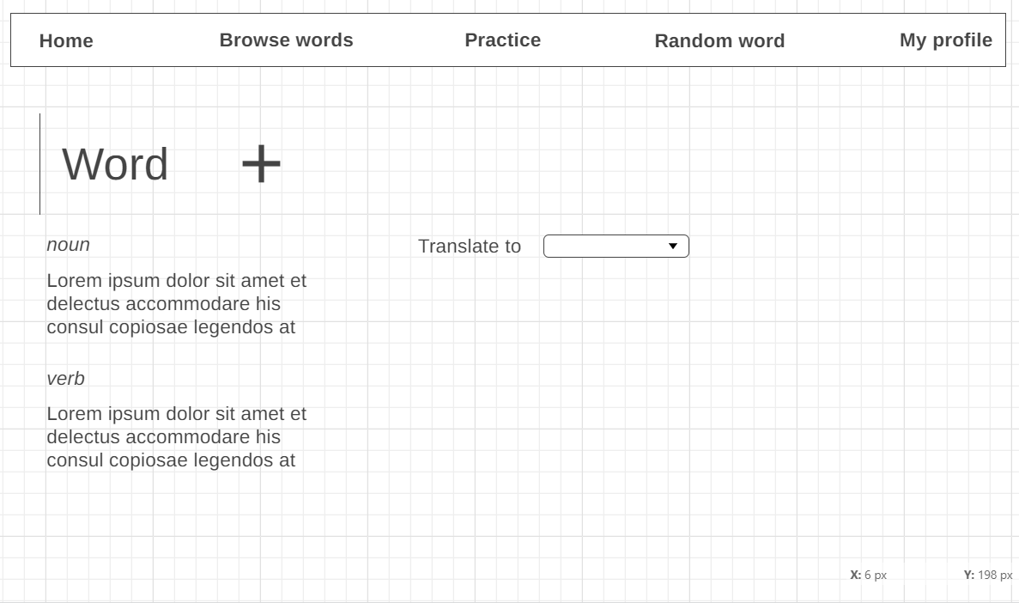Si